1) A)

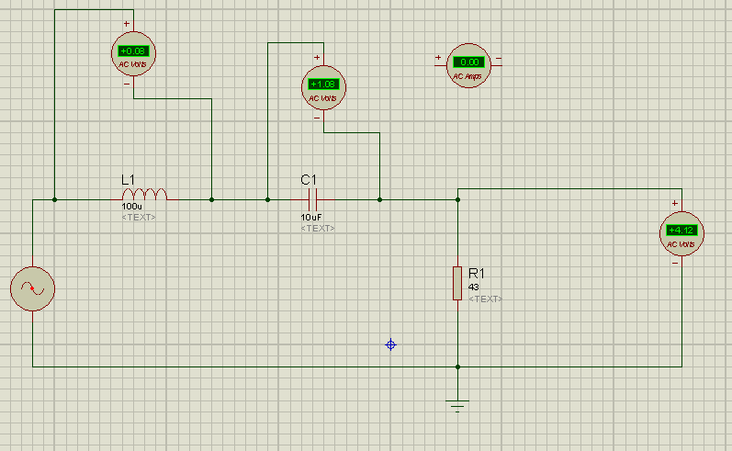

VR=4.12V , VL=0.08 , VC=1.08

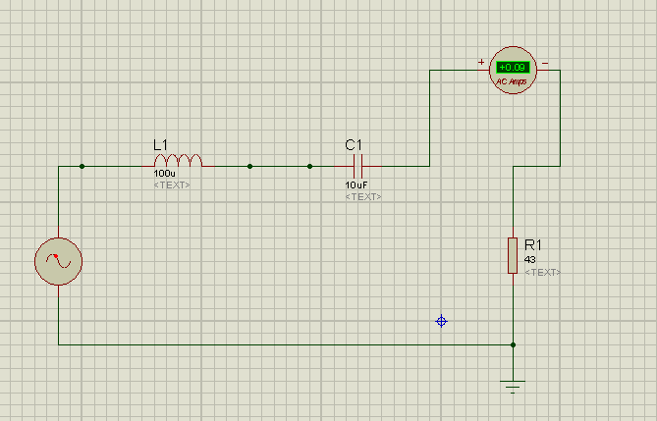

I = 0.09 A

B) 1) f=0.5 kHz

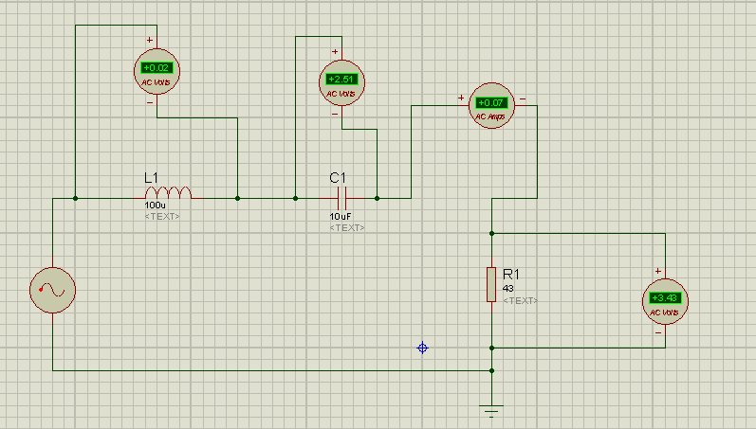

VR=3.43V , VC=2.51 , VL=0.02 , I =0.07 A

2) f=1.4kHz

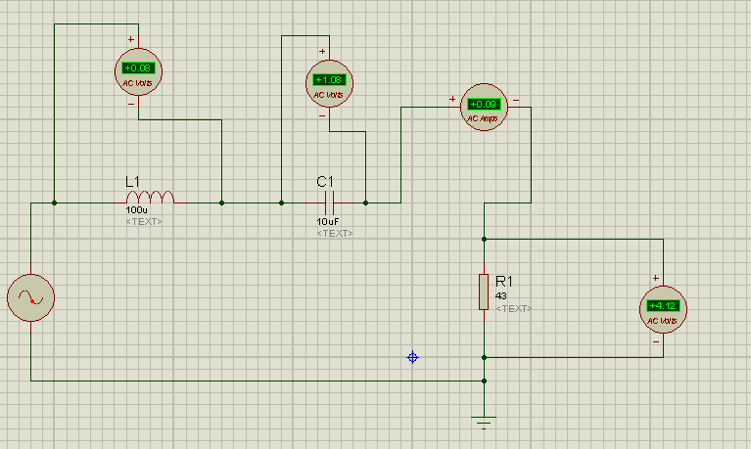

VR=4.12 V , VC=1.08 V , VL=0.08 V , I =0.09 A

3) f=3 kHz

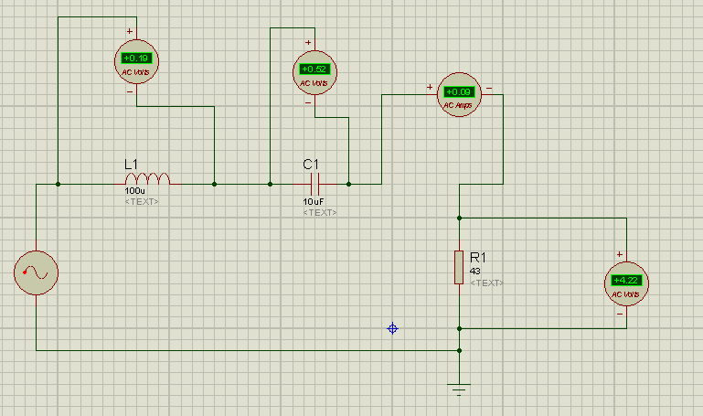

VR=4.22 V , VC=0.52 V , VL=0.19 V, I =0.09 A

4) f=20 kHz

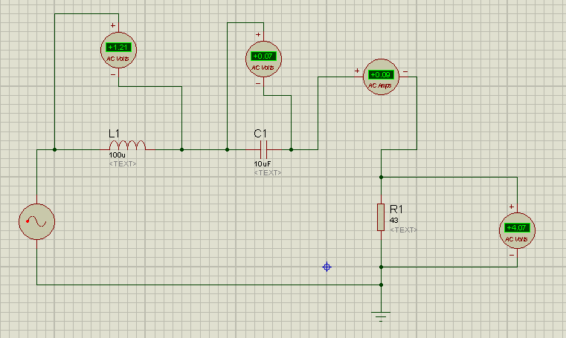

VR=4.07 V , VC=0.07 V , VL=1.21 V , I = 0.09 A

5) f=100kHz

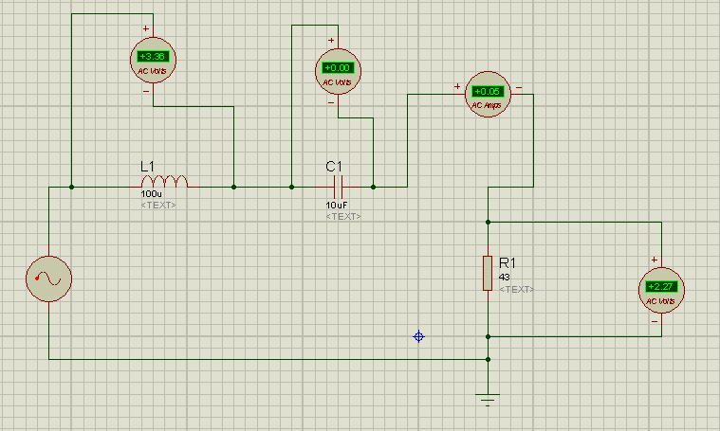

VR=2.27 V , VC=0.00 V , VL=3.36 V , I =0.05 A

6) f=250kHz

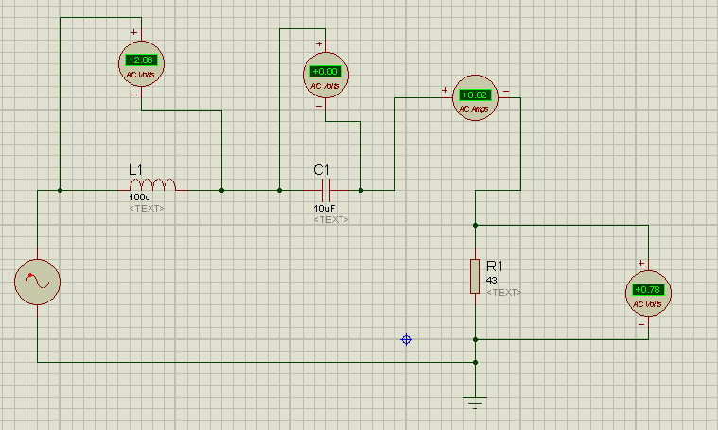

VR=0.78 V , VC=0.00 V , VL=2.86 V , I = 0.02 A